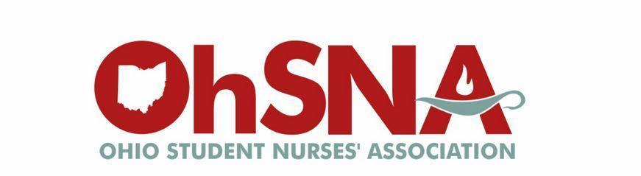

2023-2024
Candidate’s Information Packet

Please return pages signed to kfernandez@capital.edu by October 1, 2023

All meetings will take place at Capital University (central to all schools in Ohio) and a zoom option is available if you are unable to make it in person.

Board member positions and descriptions can be found on our website: https://www.ohiostudentnurses.org/

Ohio Student Nurses’ Association
Board of Directors Candidate Application

Candidate for the Office of: ________________________________________________

Second Choice: __________________________________________________________

Biographical Information (Please Print):
Name: ________________________________________________________________
Current Address: ____________________________________________
City: _______________________________ State: _____ Zip Code: ______________

Phone Number: (_______) _________-_____________
E-mail Address: __________________________________________________________

School of Nursing: _______________________________________________________
City: _______________________________ State: _____ Zip Code: __________________
Length of Program (years): ____________________Year in Program: _______________
Expected Graduation Date (month/year): ________________________________________

NSNA Membership Number: ________________________Expiration: ________________

What ideas will you bring to the board if elected to this position?

Please describe student leadership activities:

Please tell us about yourself in up to 50 words. Please include your biographical information, goals, interests, hobbies, and current leadership roles. If elected, this information may be placed in your bio on the OhSNA website.

Consent to Serve
If elected, I hereby promise to pledge my loyalty and support in the execution of the responsibilities, which accompany the office of________________________________, I am fully aware of the nature of this position. In the event I am unable to carry out my responsibilities, I agree to resign the office with the advice of the OhSNA Board of Directors. I understand that I must attend the future board meetings if elected to this position. I also give my permission to the OhSNA Advisor to verify my academic standing and enrollment each semester of my elected term.

Signature: _____________________________________ Date: _____________________

Dean’s Statement of Support
Please ask your program’s dean, student nurses’ association advisor, or other representative faculty to sign the following portion of consent
☐ I confirm that this candidate is in good standing per the academic policy at our institution.
☐ The faculty and administrators at this institution are willing to accommodate the candidate’s leadership responsibilities, including providing alternate test dates and providing alternate clinical days or allowing leadership experiences to count for a limited number of clinical hours.
Dean Statement:

Name: __________________________________________________________________________________

Signature: ____________________________________________________ Date: _____________________

Title: ___________________________________________________________________________________

Contact phone or email: __________________________________________________________________

To be completed by the Nominations and Elections Chairperson:
Date received: ___/___/___ Signature:_____________________________________________________

Please Return all Applications/Consent to serve forms along with an headshot (.jpeg) by:
Sunday, October 1st, 2023 if pre-slating. Email completed application to: kfernandez@capital.edu
Board of Directors Code of Conduct
In accepting my position on the OhSNA Board of Directors, I agree to OhSNA’s Code of Professional Conduct for the Board of Directors. I agree to fully abide by the constitution, bylaws, rules and regulations of OhSNA, as well as federal, state, and local laws and regulations. As an OhSNA Board member, I will:
1. Represent the interests of all people served by this organization.
● Board Members are elected by the entire House of Delegates and have a responsibility to represent the entire OhSNA membership, not their school, state, election area, or special interests.
2. Act in the best interest of OhSNA
● Exercise ordinary and reasonable care in performing duties and put the association’s best interest ahead of other interests.
3. Accept my Duty of Care to make decisions based on research, legal and financial counsel (as needed), and critical thinking that evaluates the short and long term impact of decisions upon OhSNA.
● Respect and fully support the duly made decisions of the OhSNA Board in accordance with their fiduciary duties of obedience and loyalty. This includes my publicly supporting and representing the duly made decisions of the OhSNA Board. During decision making meetings, I accept my responsibility to understand the issues and to participate in discussions and decisions as appropriate.
● Not take any public position representing OhSNA on any issue that is not in conformity with the official position of the association.
● Not use or otherwise relate my affiliation with the OhSNA Board to independently promote or endorse candidates or parties for the purpose of any OhSNA or other student or non-student election (local, state, or national).
● Not use or otherwise relate my affiliation with the OhSNA Board to independently promote or endorse candidates or parties for the purpose of any OhSNA or other student or non-student election (local, state, or national).
● Not use or otherwise relate my affiliation with the OhSNA Board to independently promote or endorse products and services not endorsed by OhSNA.
4. Avoid Conflicts of Interest.
● Be accountable to OhSNA above all else. I will not use the organization or my service on the OhSNA Board for personal advantage or for the advantage of friends, family, school/state chapter, or supporters (campaign promises). (Refer to OhSNA Conflict of Interest Policy).
● Not seek or accept, on behalf of myself or any other person, any financial advantage or gain that may be offered because or as a result of my affiliation as a Board member of OhSNA.
5. Keep confidential information confidential.
● When correspondence and documents are marked “confidential,” I will keep information confidential (i.e. all contract negotiations are confidential).
● I Maintain full confidentiality of information obtained as a result of OhSNA Board service in accordance with OhSNA Board policy or direction. 6. Approach all OhSNA Board issues with an open mind and be prepared to make the best decision for the whole organization.
● As an OhSNA Board member, I will not make my personal decision or make any commitment to others to vote a particular way on an issue before participating in a deliberation session in which the matter is to be discussed and action duly taken. Every OhSNA Board member has the right to be heard prior to decision-making by the OhSNA Board. All deliberations should take place in official meetings. Governance is a collective act.
● Respect the work and recommendations of all OhSNA committees who are duly charged and have convened and deliberated accordingly.
7. Never exercise authority as an OhSNA Board member except when acting in a meeting with the full OhSNA Board or as delegated by the OhSNA Board.
● I agree to exercise caution when expressing opinions or sharing information with members at my own or other school chapters and when attending state meetings. I will refrain from “appearing” to be acting with the authority of the OhSNA.
8. Focus OhSNA Board efforts on OhSNA’s Mission and not on personal goals.
● OhSNA Board members as individuals have no individual authority over the organization. Each ONSA Board makes decisions in formal sessions as a collective governing body keeping OhSNA’s Mission in mind. Contact OhSNA 's President for any questions related to the OhSNA 's Code of Professional Conduct for the Board of Directors and know their roles include providing information and support to all the OhSNA Board members.

NAME:

DATE:

SIGNATURE:

